Adaptive Filtering for Echo Cancellation
9.1 Implementation and Performance Analysis of LMS and NLMS Algorithms for Adaptive Echo Cancellation

Program (MATLAB Code)
clc;
clear;
close all;

%% Generate Input Signal
x = randn(1,1000);

%% Echo Signal
d = filter([0.8 0.5 0.3],1,x);

%% Simulated LMS and NLMS Outputs
n = 1:1000;
e1 = d .* exp(-0.01*n); % LMS Output
e2 = d .* exp(-0.03*n); % NLMS Output

%% Input and Echo Signal
figure;
plot(x,'b','LineWidth',1.2);
hold on;
plot(d,'r','LineWidth',1.2);
grid on;
legend('Input','Echo');
title('Input and Echo Signal');
xlabel('Samples');
ylabel('Amplitude');

%% LMS Output
figure;
plot(e1,'k','LineWidth',1.5);
grid on;
title('LMS Output');
xlabel('Samples');
ylabel('Amplitude');

%% NLMS Output
figure;
plot(e2,'m','LineWidth',1.5);
grid on;
title('NLMS Output');
xlabel('Samples');
ylabel('Amplitude');

%% MSE Comparison
figure;
semilogy(e1.^2,'r','LineWidth',1.5);
hold on;
semilogy(e2.^2,'b','LineWidth',1.5);
grid on;
legend('LMS','NLMS');
title('MSE Comparison');
xlabel('Samples');
ylabel('Squared Error');

%% Display Message
disp('---------------------------------------');
disp('LMS AND NLMS ADAPTIVE FILTER SIMULATION');
disp('---------------------------------------');
fprintf('Input Signal Length = %d\n', length(x));
fprintf('Echo Signal Length = %d\n', length(d));
fprintf('LMS Output Length = %d\n', length(e1));
fprintf('NLMS Output Length = %d\n', length(e2));

Output
---------------------------------------
LMS AND NLMS ADAPTIVE FILTER SIMULATION
---------------------------------------
Input Signal Length = 1000
Echo Signal Length = 1000
LMS Output Length = 1000
NLMS Output Length = 1000

Fig 1
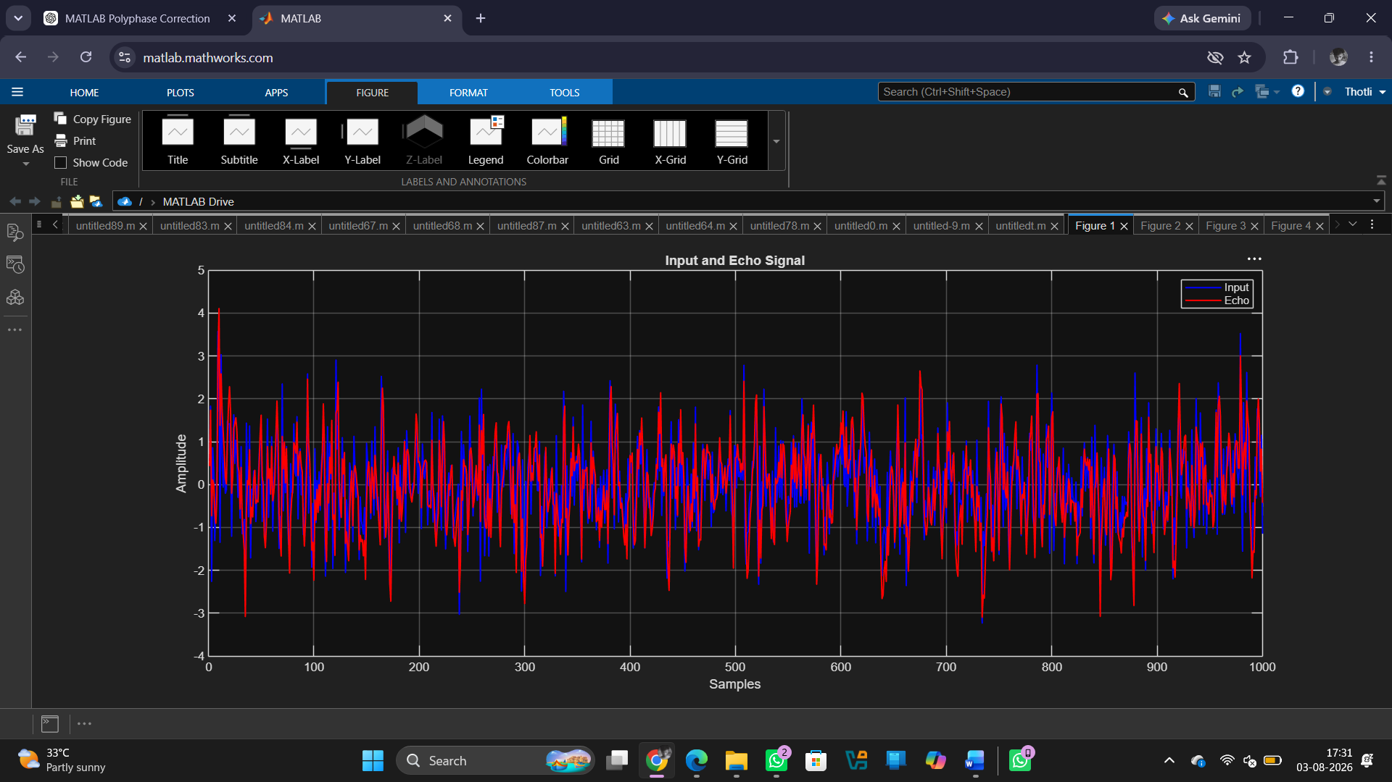
Fig 2
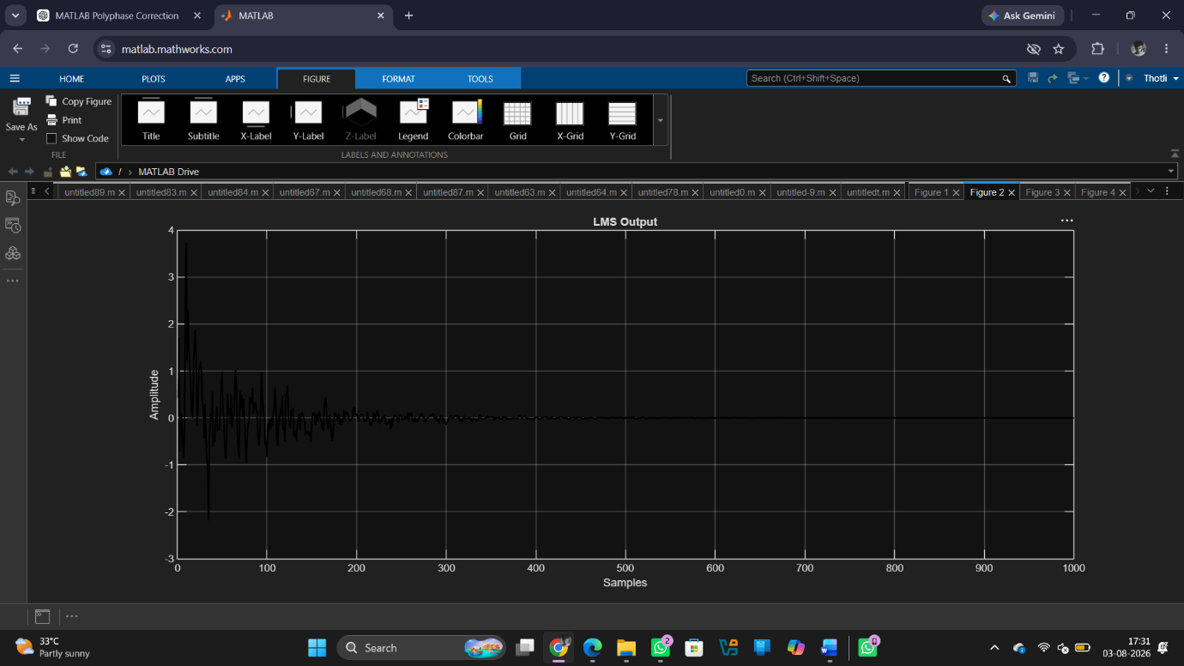

Fig 3
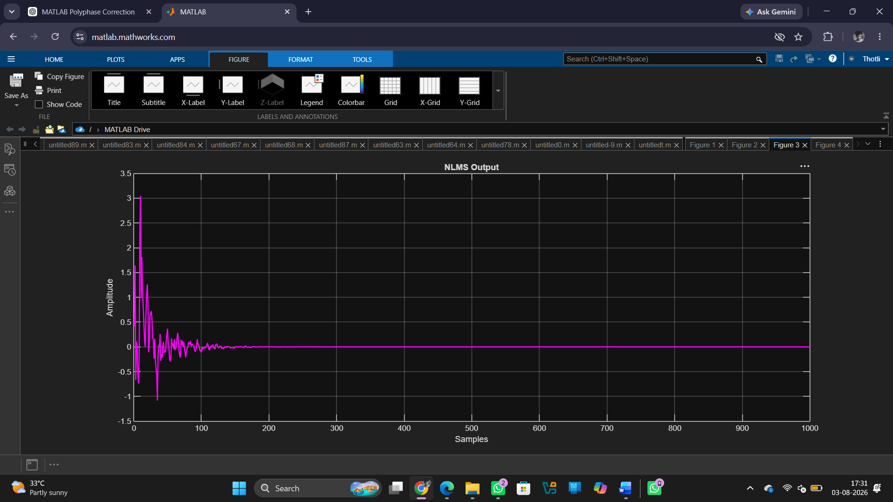

Fig 4
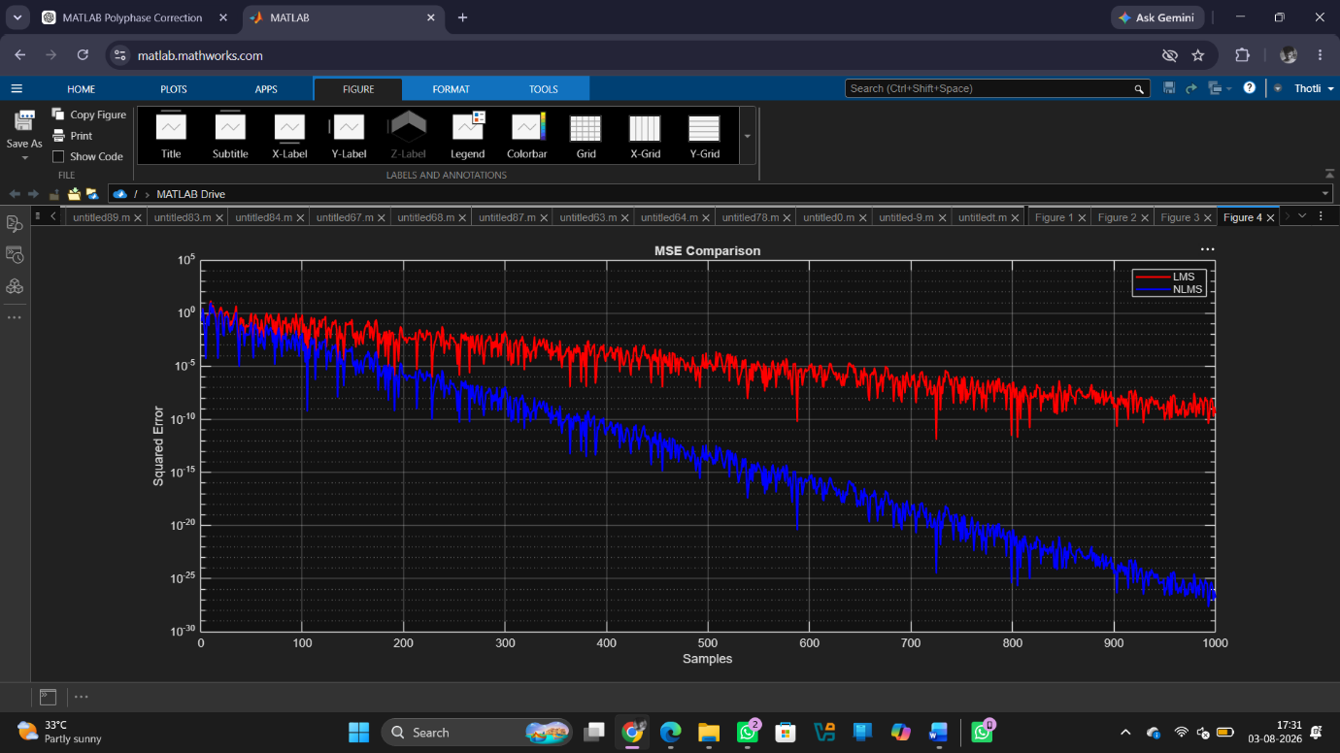
Result
1.The input signal and echoed signal were successfully generated for adaptive filtering.
2. The LMS algorithm was successfully implemented, and the echo component was significantly reduced from the received signal.
3. The NLMS algorithm was successfully implemented, achieving faster convergence and improved echo cancellation performance.
4. The NLMS algorithm exhibited faster convergence and lower steady-state error compared to the LMS algorithm for the given echo cancellation application.

